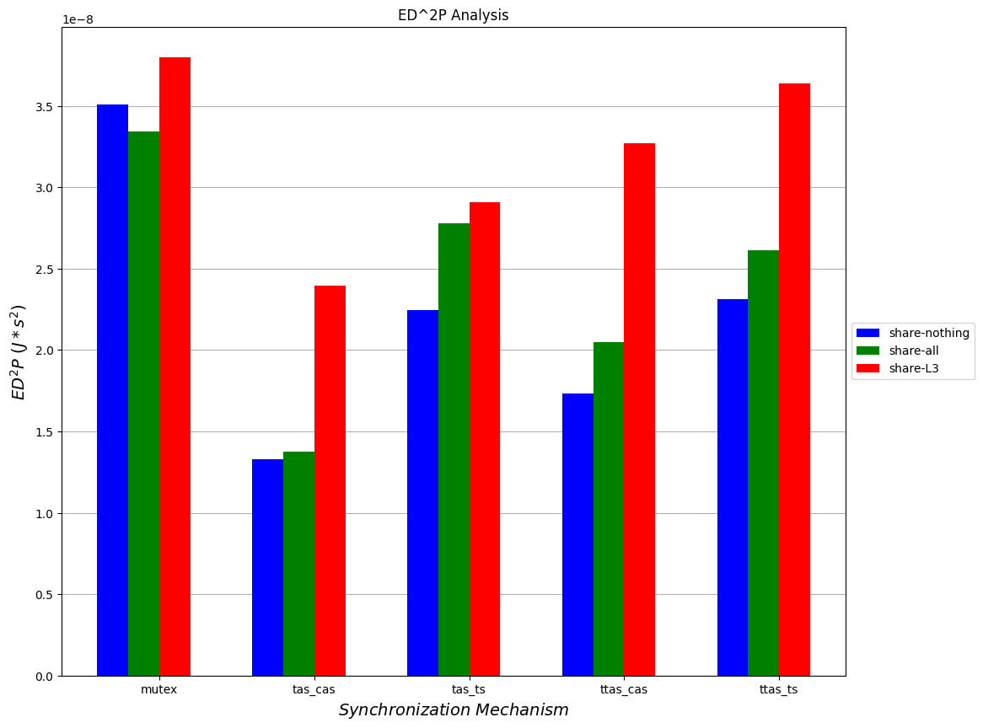

**le-8**

ED^2P Analysis

*ED2P (/*52)*

share-nothing share-all share-L3

mutex

**ttas_cas**

**ttas_ts**

**tas_cas**

*tas_ts Synchronization Mechanism*